There is a copy of the 14th edition of our textbook on

2 hour reserve at the UHCL library.

Ask for PERC 002

Title is: Earth Science

Authors are Tarbuck and Lutgens

The capacity to learn is a gift;
the ability to learn is a skill;
the willingness to learn is a choice.
~Brian Herbert

What is the purpose of an education?

“The more I learn, the more I realize how much I don't know”
Einstein

"It ain't what we don't know that gets us into trouble, it's what we know that ain't so!"

Bulls

Hair

Einstein

Life expectancy

Flat Earth

"What really gets us into trouble is not even knowing what we don't know".

Lead

Mercury

Black Death (Bubonic Plague)

"Ignorance more frequently begets confidence than does knowledge"

How do you pronounce the capital of Kentucky? Loo-ee-ville or Loo-iss-ville

How much money would you bet that you know the correct answer: $5, $50, $500? Answer is Frankfort Kentucky

- Excess confidence leads people to think too highly of their skills

Things are not as they seem

The Earth travels around the sun at 100,000 km/hr (66,000 mi/hr)

The Earth spins once each day, we spin at 1,670 km/hr (1,000 mi/hr)

The Earth hurtles toward the Andromeda galaxy at 400,000 km/hr (250,000 mi/hr)

And yet we feel as though we are not moving at all.

Most of the ancient people felt we were the center of the universe.

Correlation versus Causation
Stock Market versus Super Bowl Champion

When the National Conference wins the stock market goes up, when the American Conference wins the stock market goes down.

However, Scientific theories often start as a correlation.

Charles Darwin’s 5 year voyage in 1831 studying animals and plants
Each Island in the Galapagos was different with different food
He found the same animal or plant in a different environment was very different
This led him to the theory of Natural Selection – published in 1859.
But how this happened wasn’t understood almost 100 years.

Johann Mendel (father of Genetics) studied pea plants – 1856 to 1863
Found there were dominant and recessive characteristics
Breeding tall plants and short plants gives mostly tall plants and some short plants
Each characteristic (Gene) is independent of the others.
Thomas Hunt Morgan studied fruit flies in 1910 (thinking that Mendel was wrong) and discovered chromosomes were the inheritance mechanism.
Oswald Avery studied the role of bacteria in diseases in 1904.
Found that benign bacteria could change into a virulent form.
Published in 1944 that DNA held the chromosomes.
Watson and Crick discovered the structure of DNA (double Helix) in 1953

So about 100 years later we understood how Darwin’s finches changed.

Science is the belief in the ignorance of experts
Richard Feynman, 1969

General Skills

-Conversion of Temperature

General Skills

-Conversion of Temperature (The old way)
T (Celsius) = (T (Fahrenheit) - 32) *5/9
T(Fahrenheit) = 9/5 T(Celsius) + 32

This is the hard way. Don't do it this way!

Method to convert temperature

deg C to deg F

or deg F to deg C

The easy way

1) Add 40

2) for deg C to deg F multiply by 9/5

for deg F to deg C multiply by 5/9

3) Subtract 40

Expressed as single formulas

F = ((C+40)*9/5)-40

C = ((F+40)*5/9)-40

Unit Conversions

Example 1

If sea floor spreading in the Atlantic = 2 cm/year

& the Earth's magnetic field reverses each ≈ 1,00,000 years

How wide is each magnetic strip (in km?, in miles?)

conversions (cm = centimeter, m = meter, km = kilometer, ft =feet)

100 cm = 1 m

1 km = 1000 m

1 m = 3.281 ft

1 mile = 5280 ft

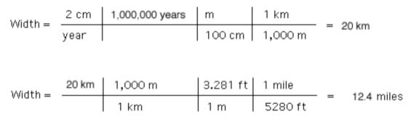

Example 2

The Curie point is that temperature above which magnetism is lost = 580 deg C. Earth's surface is about 30 deg C.

If the temperature inside the Earth increases by 30 deg C each km of depth, at what depth does magnetism of the Earth's rocks disappear.
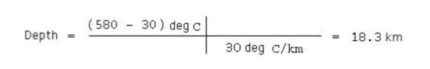

General Skills

Julian Days are the number of days since 12 noon

January 1, 4713 B. C.

for example August 28, 2018 is Julian Day 2,458,723

It is also day of year (DOY) 240

Julian Calendar Named for Julius Scaliger Convenience for astronomers (no leap years, leap centuries).

Julian Calendar (named after Julius Caesar) was used starting in 45 B.C. to make the calendar back in sequence with the seasons.

It had leap years too, but became out of sync with the seasons

Replaced with the Gregorian calendar in 1582.

Accuracy and Precision

PRECISION - A measure of the variability of repeated tries.

BIAS - A measure of the difference between the estimate
and the truth.

ACCURACY - Includes both bias and precision.
Geologiccal Time Scale showing extinctions

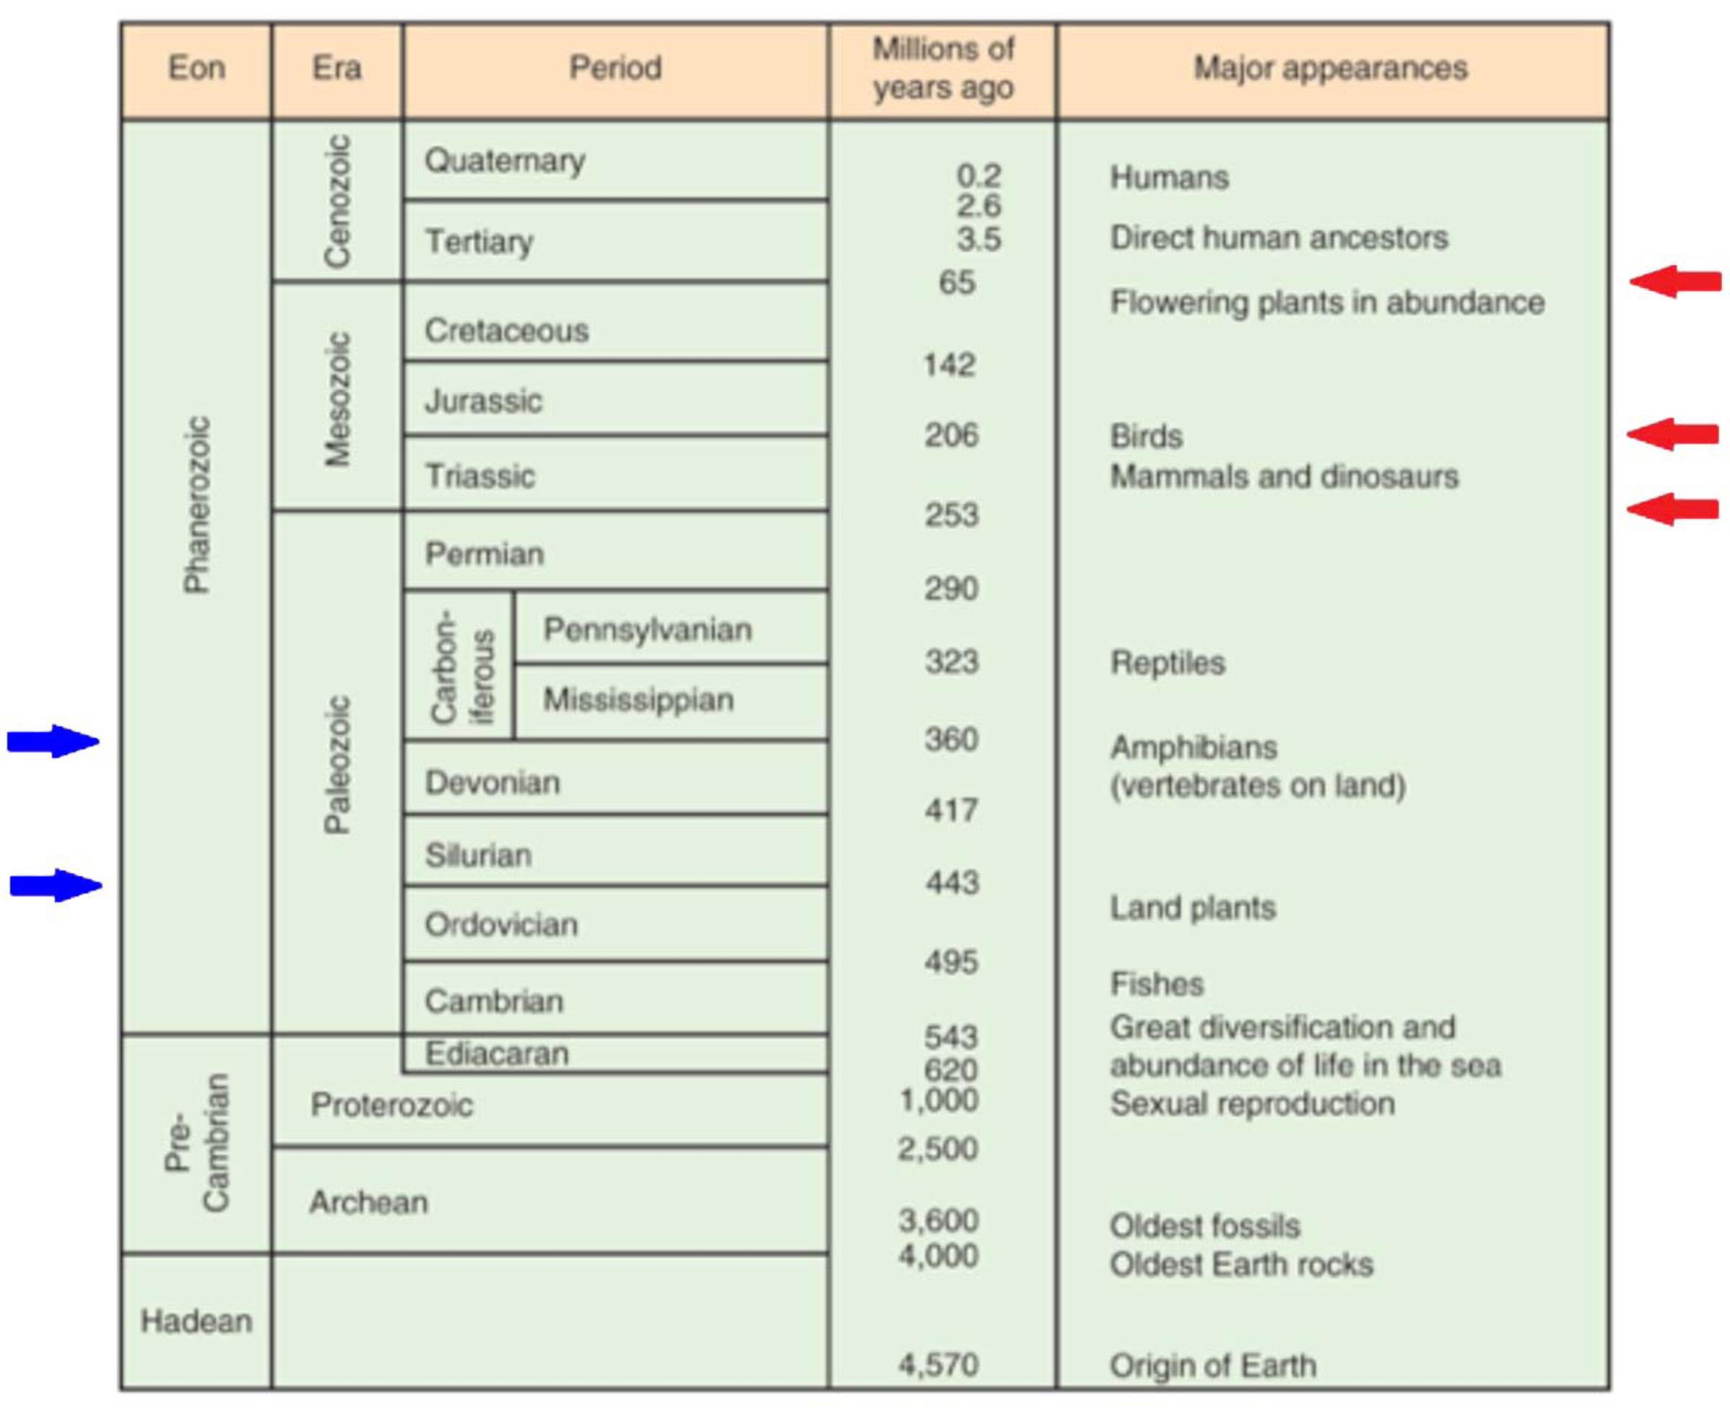

Oxygen created by photosynthetic bacteria 3.5 BYA

Single cells first just divided, then about 1 BYA single cell eukaryotes sexually reproduced by transferring genes between cells before division.

620 MYA the Ozone layer formed and this protected land dwelling multicellular animal life.

Extinctions at the end of the Ordovician and the end of the Devonian were link to global cooling. Blue

Permian-Triassic extinction (loss of 83% of life) Sea surface waters warmed by 8-10 deg C due to volcanic eruptions (Emeishan Traps in China) increasing Carbon Dioxide levels in the atmosphere. Red

End of Triassic was hot and dry and caused a 47% extinction. Red

Deccan Traps (massive volcanic eruptions one mile deep and the size of California in India) occurred about the same time as the Chicxulub Asteroid Impact 66 MYA and may have been caused by the impact. Red

Rocks are made up of minerals. For example Granite can have different amounts of quartz, feldspars, biotite and muscovite mica, amphibole, and pyroxene.

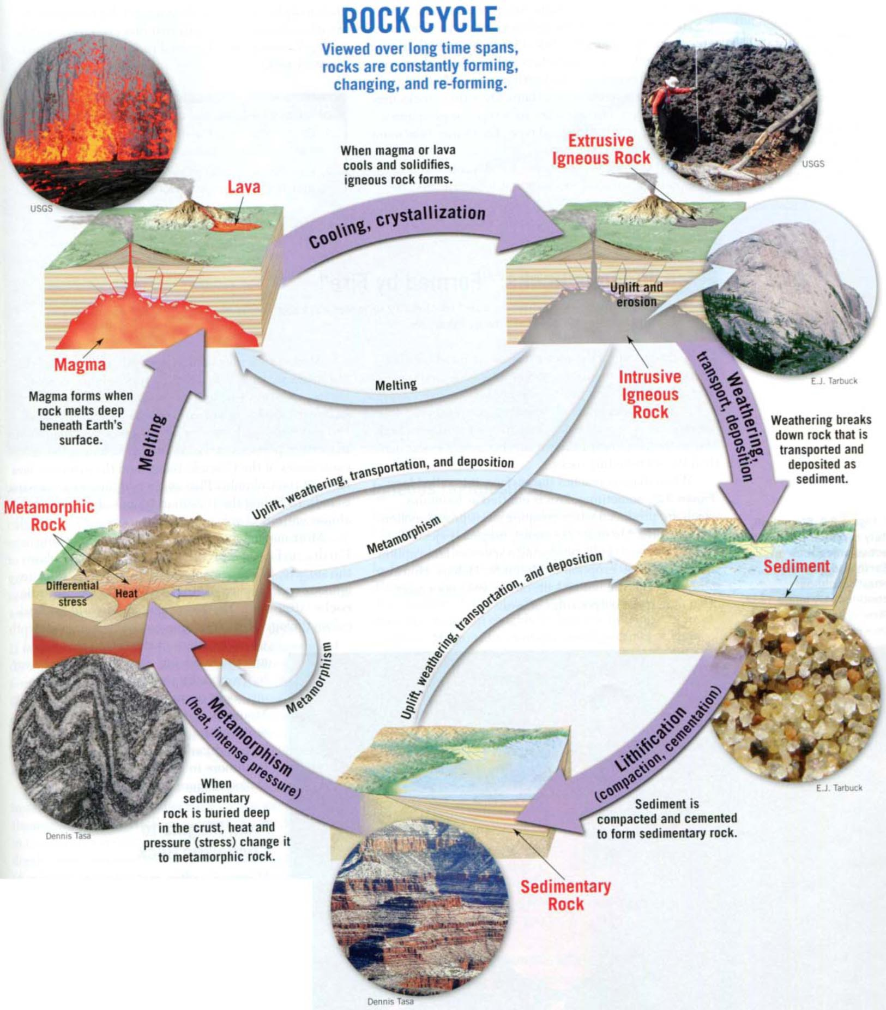

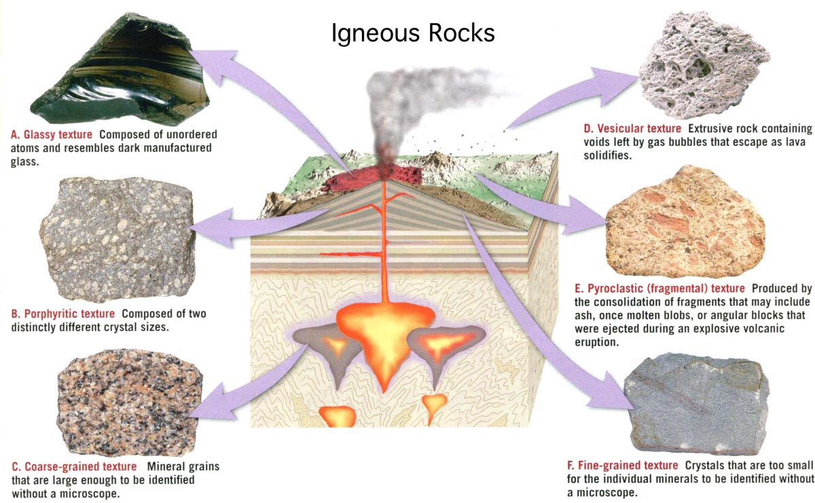

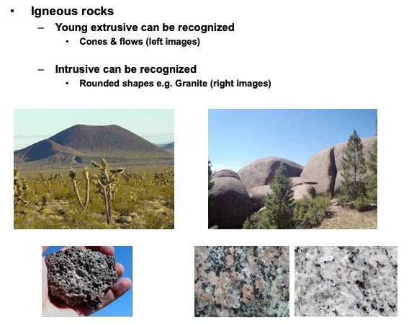

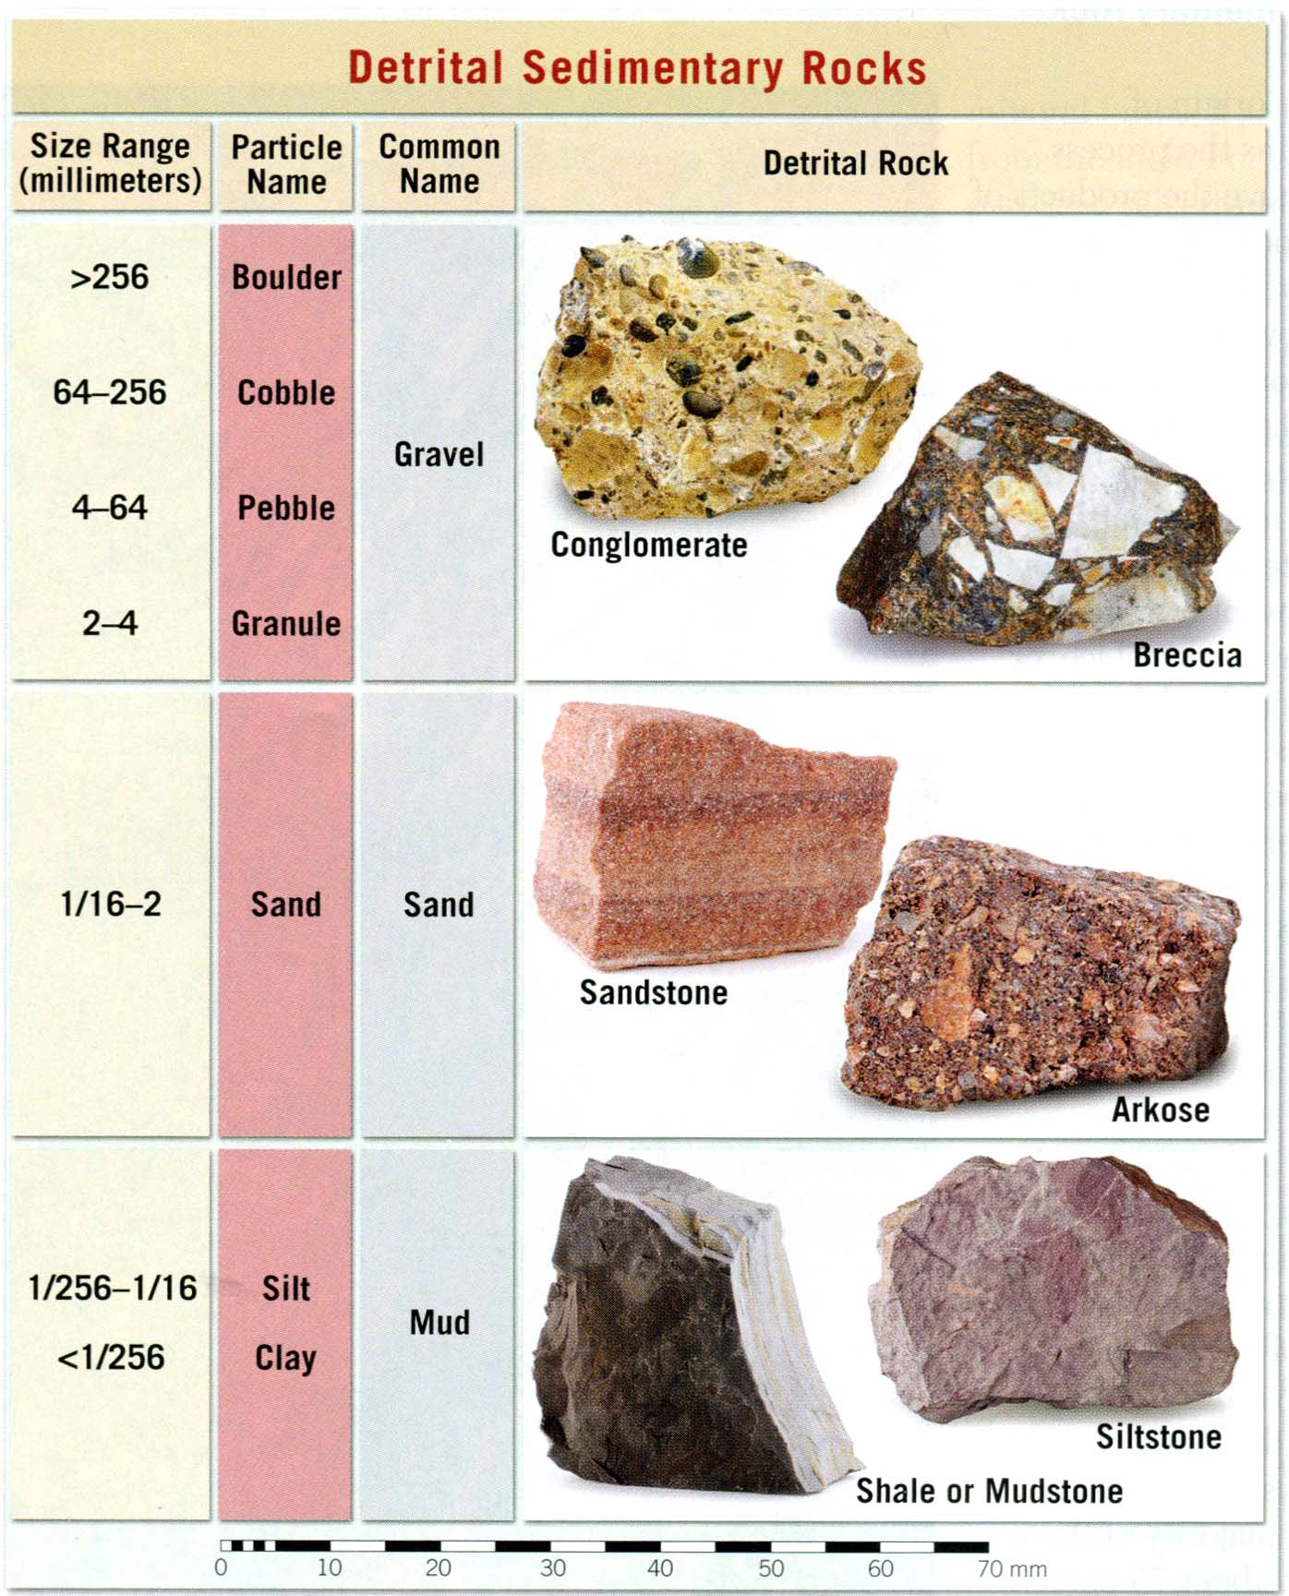

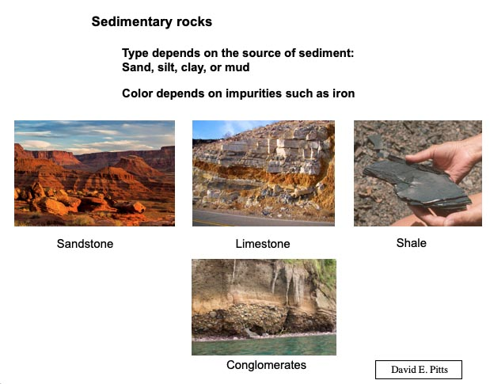
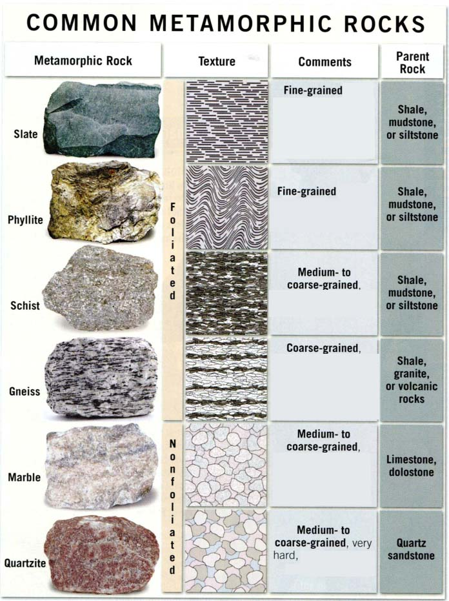

Topographic Maps give you elevation information

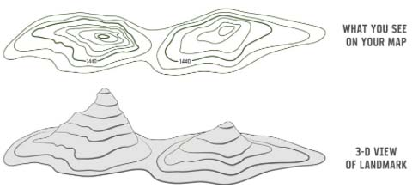

Topographic Maps provide slope steepness

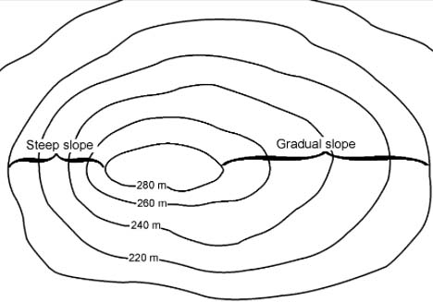

Topographic Maps have Legends to identify features

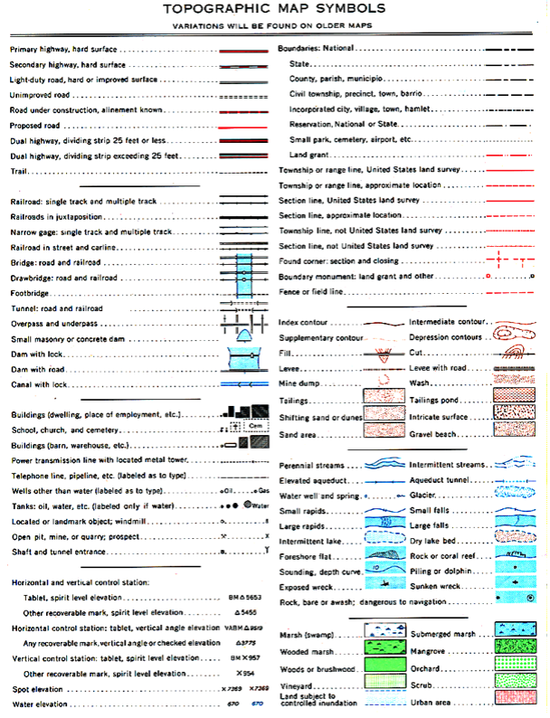

Induction and Deduction

Deduction (the situation where we know the rule)

Rule

All dogs are animals.

This is a dog.

Therefore, this is an animal
_______________________________________________
Induction (scientific method, trying to figure out the rules of the universe)

- Metals are tested.

- Observation - Every metal I've tested expands when heated.

- Therefore I expect all metals to expand when heated.

- After testing this becomes a workable theory

- Verification (proof) requires testing all metals in the universe (impossible).

- Continue testing is done. If a test disagrees with the theory (a counter example), then the theory must be changed.

Inductive Logic

Sir Francis Bacon (1561 - 1626)

Entered Cambridge University at age 12

Father of Induction

Using experiments to refute or support a hypothesis (Not prove).

Greek science relied heavily on deduction

Induction established as "the scientific method" at Cambridge University about 1830 by Herschel, Babbage, Whewell, and Jones.

Inductive Logic

This is the "Scientific Method"

The term "scientist" was coined by William Whewell at Cambridge University in 1833.

Eleusis
A game of Inductive Logic

For the rules see the GEOL 3305 website

